Social Engineering and Password Patterns
You will be provided with an employee profile. You will use their personal and biographical information to guess their password, recover a secret message, and read the temperature from the IoT office to prove that you have access to their smart devices.
When you succeed, describe in the report how their passwords are not following best practices for password security. Suggest better practices and improvements for the future.
Evidence for the report:
- Include the guessed password and username
- Recover the secret message
- Read the temperature data from the IoT office
- Identify and list what best practices weren’t followed

In the folder, you will find a file called Employee Profile.txt, which contains personal information about an employee. The username and password she uses to log into IoThouse are derived from this information. Your task is to identify the correct username and password.

Step 1: Extract Relevant Terms
First, you need to extract potential terms that could be used to form usernames and passwords from the text. You can manually search for relevant terms, or you can use a program to extract them (which is recommended). These terms will include words and numbers that appear in the text, such as her birthdate.
When extracting words programmatically, you can use the provided NLTK's list of English stopwords to filter out common words like "is", "to", and "and", which do not add meaning. This step is commonly used in natural language processing (NLP) to narrow down the term selection.
The final list of potential terms will not exceed 35 terms in total.

Step 2: Generate Potential Username and Password Lists
You will create two sets of username and password combinations for this task: Level 1 and Level 2.
Level 1:
- Username Rules:
  - Single term (one word).
  - Only terms that start with a letter (exclude terms that begin with numbers, such as 03, 14, 1984, etc.).
  - Examples: arsenal, walthamstow, emily, daniel, etc.
- Password Rules:
  - Combination of two terms (concatenation of two words).
  - Both terms must start with a letter (exclude terms starting with numbers).
  - Do not use the same term twice (e.g., arsenalarsenal is incorrect).
  - Examples: walthamstowsecurity, emilydaniel, etc.
Level 2:
- Username Rules:
  - Single term (one word).
  - Only terms that start with a letter (exclude terms that begin with numbers).
  - Same as Level 1.
- Password Rules:
  - Combination of two terms (concatenation of two words).
  - Terms that start with numbers are allowed (e.g., 03, 14, 1984, 2002, etc.).
  - Do not use the same term twice.
  - Examples: walthamstow2016, 03emily, 19842002, walthamstowlifelong, etc.
You need to use these rules and combine the terms in your list to create potential usernames and passwords for Level 1 and Level 2. You will generate a username list and a password list for each level. These lists will be used for the brute-force attack.

Step 3: Perform the Brute-Force Attack
Once you have your lists prepared, you need to open the brute-force server in the folder. When you open it, you will see a terminal window. You can access the locally hosted Flask website at 127.0.0.1:5000.
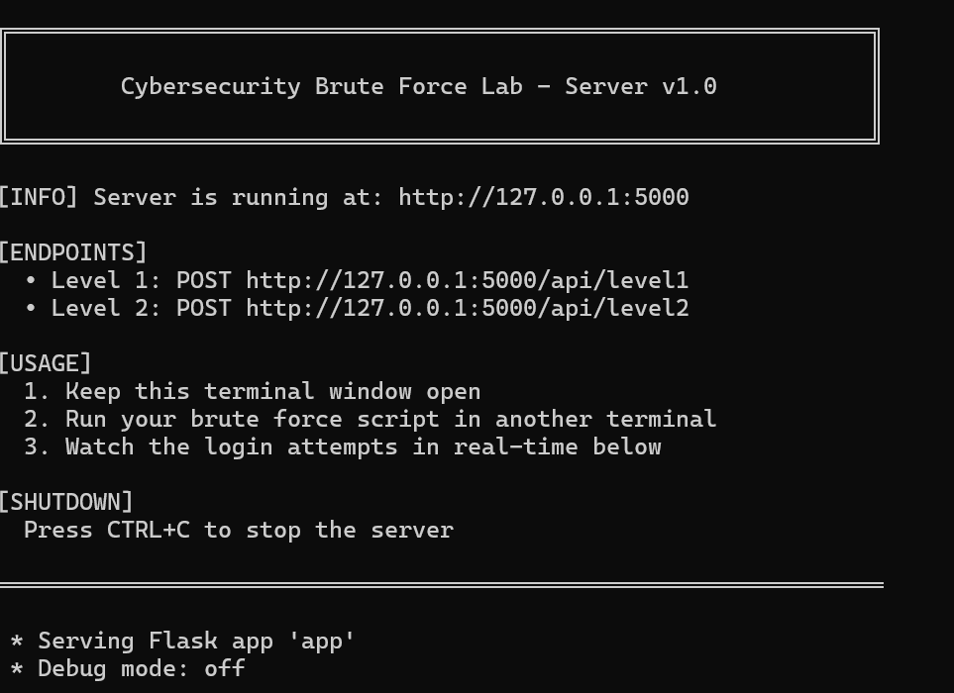
The server provides two APIs:
- http://127.0.0.1:5000/api/level1
- http://127.0.0.1:5000/api/level2
You need to use the POST method to call these APIs and attempt logins. Once you succeed, the server will return the correct username and password.
Here is an example of how to call the API in your Python script:
API_URL = "http://127.0.0.1:5000/api/level1"

# Send POST request to API
try:
response = requests.post(
API_URL,
json={"username": u, "password": p},
timeout=5
)

# Check if login was successful
if response.status_code == 200:
data = response.json()
if data.get("success"):
found = True
found_username = u
found_password = p
secret_message = data.get("secret")
break
except requests.RequestException:
continue

Hint: The level 1 attack might take around 5 minutes, and the level 2 attack might take around 15 minutes.
Once you log into IoThouse using Level 2 credentials, you will need to access the current indoor temperature data (with a timestamp) and take a screenshot of it.

Step 4: Analyze the Results
- Analyze the time it takes to break the passwords for different levels.
- Roughly estimate how the number of possible combinations changes as you increase the level. Consider what happens when you add more terms or include special characters (such as @).
- How much does the number of potential passwords grow? What are the likely magnitudes of those numbers?
- Think about ways to speed up the brute-force process, such as parallelizing or optimizing your code.
- Reflect on the password design principles: What makes passwords strong? How can you design systems to avoid weak passwords?

